Chris Marshall
Operating Systems
Assignment #4

1a)
Semaphores are a data structure implemented by a notion of shared memory by several processes which relate by some critical section; either a shared resource or some other shared data. Semaphores are used to guarantee unique access to the shared resource by only one process at a time. Semaphores are usually a single bit of shared memory. This bit acts as a kind-of flag for the shared resource either showing the resource is in use or available. If the semaphore is 'locked,' the scheduler can move all other processes waiting for the semaphore into a queue and activate them once the semaphore becomes available. The semaphore notion works only with an atomic test-and-set operation. Meaning that a process MUST be able to check if the semaphore is unlocked AND then lock it in one step. Another process CANNOT be able to operate or even read the semaphore state while another process is testing-and-setting. This is atomicity.
1b)
Critical Sections are parts of a program which must only be executing uniquely on a system. The same critical section cannot be executing in two different processes at the same time. This is achieved by using semaphores. A process can lock a semaphore and thus tell other processes 'I'm executing this critical section. You must wait until I release the semaphore in order to execute your critical section.' Other processes will go into a queue or a busy-waiting loop.
1c)
Semaphores are simply a global bit floating in space. There is no encapsulation or cohesion between the semaphore and the resources it is protecting. A monitor is a data structure which is more sophisticated than a simple semaphore. A monitor controls both access and the actual shared data to itself.
1d)
Atomic transactions are actions that must appear to the outside word as if they happened all in one step. Rather, if they succeed, they must do so completely. If they fail, they must also do so completely. If an operation is atomic, it is either guaranteed to be completed or guaranteed to not do anything. This is important to not leave the system in a illegitimate state. For example, in banking, a money transfer must be atomic. In actuality, you must deduct money from one account and then add it to another account; two steps. However, if an error occurred between those actions, the bank is in a bad state as the money deducted has not been credited. Atomicity can be implemented with commit and abort operations. With a commit, changes made are not final until committed. Before a commit, you can abort and restore a previous state. In our example, when the error occurs, the database can be rolled back to before the deduction and the money is retained in the original account; not lost. After a commit, another transaction can take place. In the event of catastrophic failure, each committed transaction can be 'replayed' to reach what was the current state. However, with a notion of checkpoints, the entire history of the system need not be replayed. A checkpoint can be saved then commits from the checkpoint until current can be replayed.
1e)
N/A
1f)
Serialization is the practice of executing multiple transactions at the same time. This drastically speed up performance. Time stamping helps replay the serialized transactions in the event of failure. If each transaction is timestamped, we can maintain the correct ordering of transactions in a replay even if the conditions change and thus transactions might be able to reorder themselves naturally, the time stamps maintain proper order.
1g)
A deadlock occurs when 2 or more processes are each waiting for the other to continue. The classic dining philosophers problem exemplifies deadlock in that each philosopher picks up a chopstick to the right and waits for the left chopstick to become available. Well, each philosopher is waiting for the other to release a chopstick, but they never will release a chopstick without first having both.
Deadlock can be caused by mutual exclusion, where only one process can use a resource at a time (chopstick), hold and wait, which a process has some resources it needs and it won't give those up until it has all resources, no preemption, a process will only voluntarily release resources, circular wait, process 1 waits on 2 and 2 waits on 3 and 3 waits on 1.
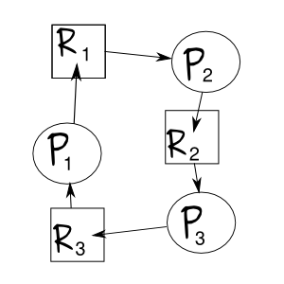
1h)
A resource allocation graph is a node-connection type graph which shows how processes and resources are allocated and requested.
1i)
The Banker's Algorithm is an algorithm which prevents deadlock by running before any process is allocated resources. The Banker's Algorithm checks that if the newly allocated resource will create a deadlock. If it will the resource is not allocated. If not, allocation proceeds. The resource graph is a visual representation of the current state of resource allocation. It can be used to check for dead lock as well, but would be implemented via Banker's algorithm.

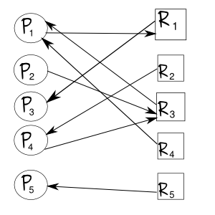
Problem 3)
There is no deadlock in the resource graph. Process 5 and 3 can both finish releasing resources 1 and 5. Then, process 1 can finish releasing resources 1, 3 and 4. Then process 2 can finish releasing resource 3. Then process 4 can finish.

Problem 4)
